**S/4HANA 2021 FPS01 OP SERVER ACCESS**



**WWW.anubhavtrainings.COM**

**Anubhav Oberoy (Free Youtube Videos)**

**Objective: The document will guide you through steps to access the S/4HANA server offered on-demand for SAP Fiori and SAP ABAP on HANA Training.**

**When you opt for the server, you will get email like below**

**Please use below server details :-**

**On your windows run command, type mstsc (Remote desktop connection)**

**RDC IP :-** [**103.207.171.202:3388**](http://103.207.171.202:3388/)

**User Name :- yourmobuser**

**Password :- mobpassword**

**In above email, you will get the Remote Desktop user and password (RDP). You can follow below steps to connect to the remote desktop to access SAP HANA Database. Please follow below screenshot**

**1.** **Type Run in your windows system**

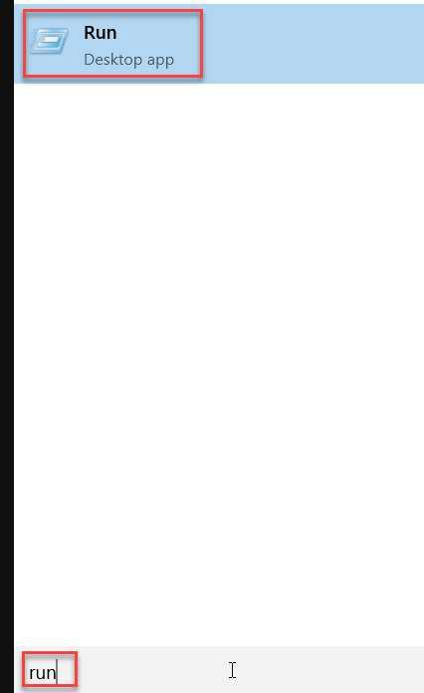

**2.** **Type mstsc in run box**

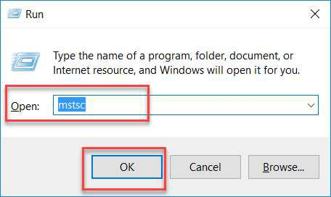

**3.** **Provide ip address of server** [**103.207.171.202:3388**](http://103.207.171.202:3388/)**, Click on Connect**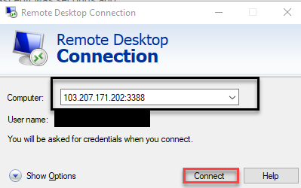

**Please check that you are using no domain name when you login first time from the logon popup of RDP.**

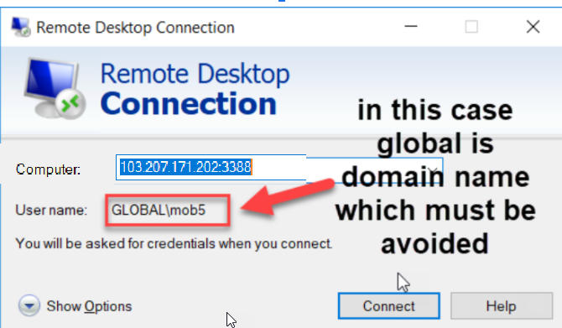

**4.** **Enter your RDP Credentials**

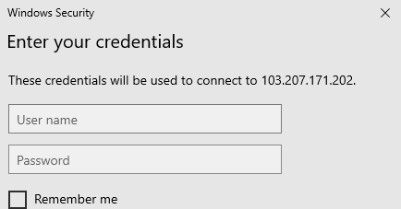

**Note: If you get Security issue in connection, please use below link**

**https://serverfault.com/questions/911590/this-could-be-due-to-credssp-encryption-oracle-remediation-rdp-to-windows-10-p**

**5.** **Confirm security popup**

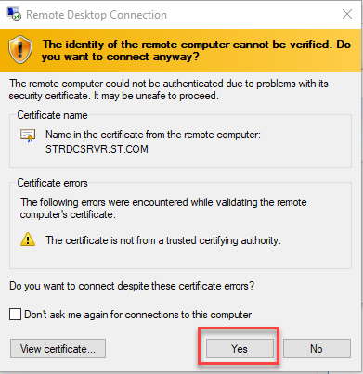

**6.** **You are connected to RDP**

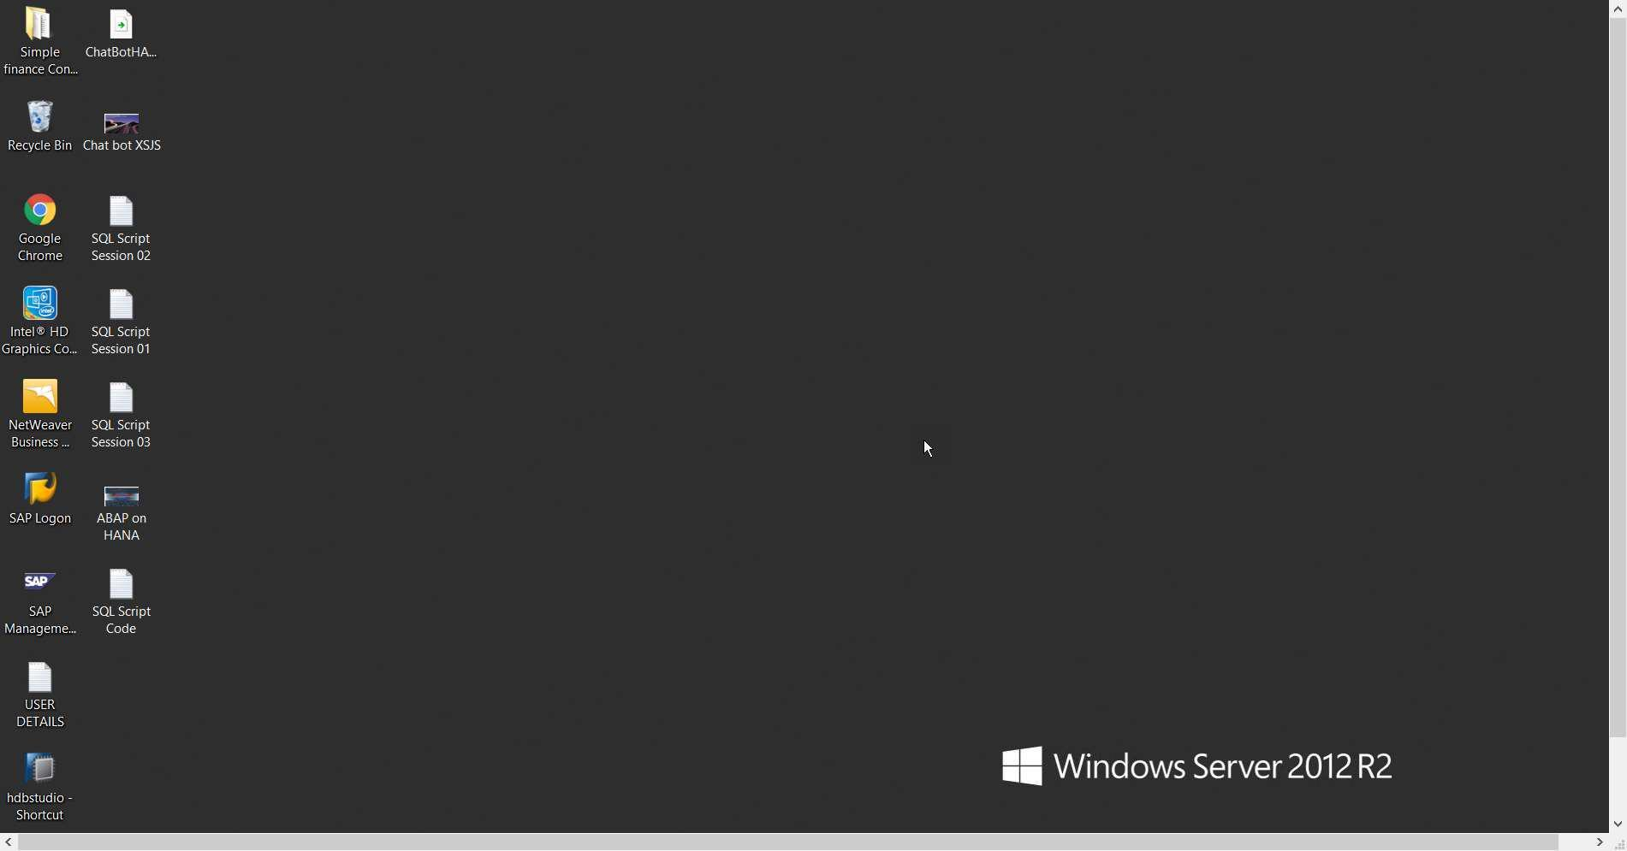

**Steps to find your HANA and ABAP system Password**

**1.** **You will find a User Details notepad file on desktop**

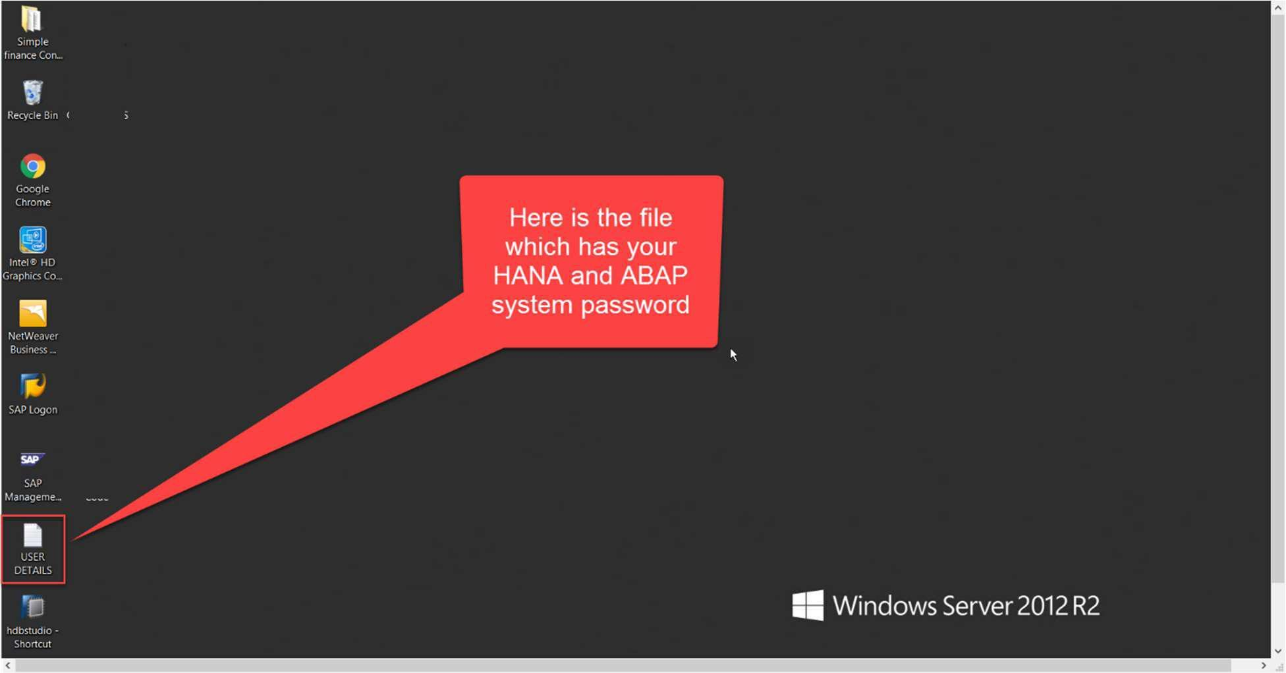

**2.** **In that you will see HANA and ABAP password.**

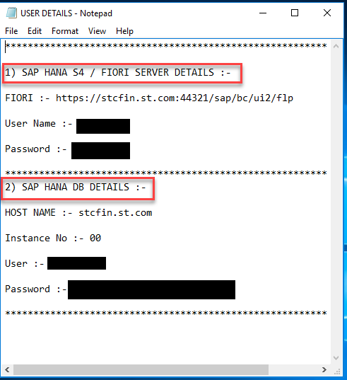

**Connecting to HANA DB in RDP**

**Please note that you can connect to HANA Database only from RDP, There is no local computer access to SAP HANA. For connecting to SAP HANA DB, The HANA Studio client is pre-installed in your server.**

**Steps are:**

**1.** **Double click on HANA Studio on desktop, if you not find the same, please search in programs.**

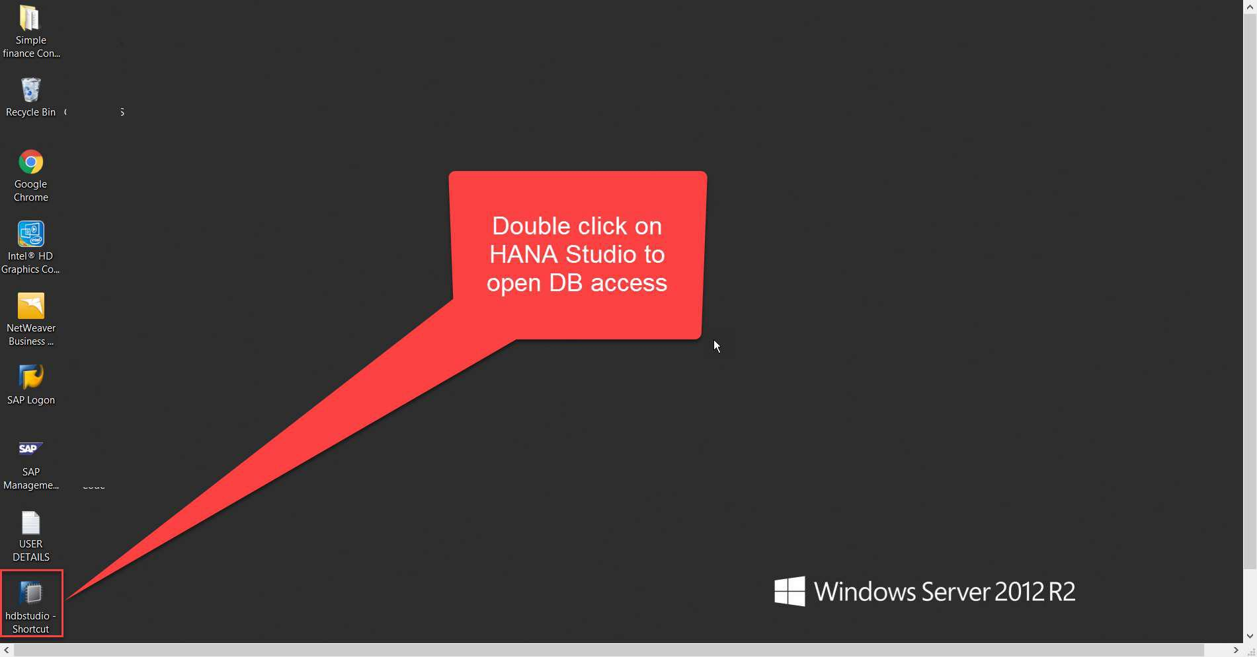

**2.** **You will get workspace popup, just click ok.**

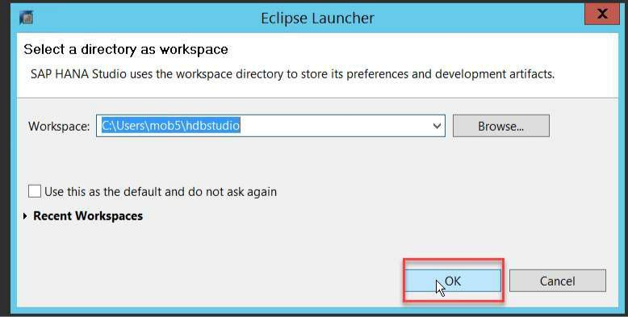

**3.** **On launch, in systems tab, if you see below issue(**Secure Storage is locked)**, please fix by using below steps**

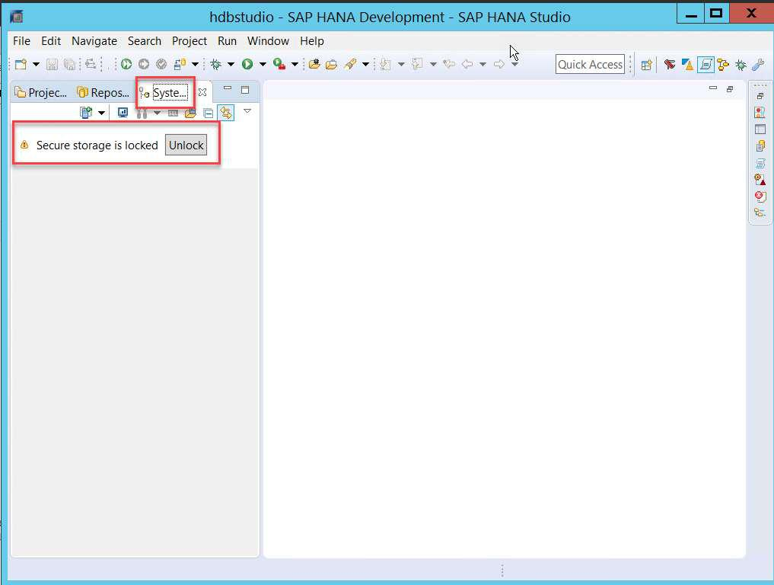

# 

# **In HANA Studio, go to Window->Preferences->General->Security->Secure Storage**

# **Switch to  <Contents> tab, and delete the default secure storage. and restart the HANA Studio.**

**4.** **If you see system, and see a gay icon, you need to logon by right clicking on system.**

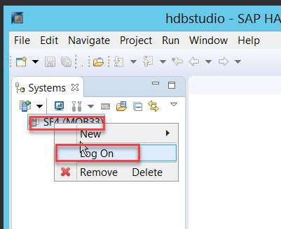

**Provide your HANA credentials as per file mentioned earlier. You will be able to connect to HANA DB.**

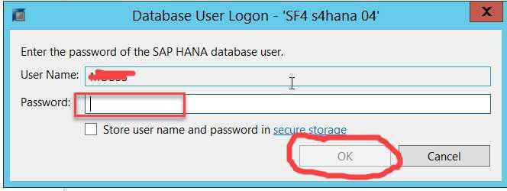

**Note: Never touch SAPABAP1 schema for any development, By default schema for your user as yourname is available for local development.**

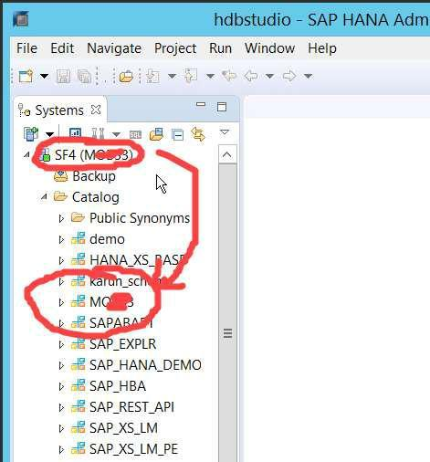

**Connecting to ABAP system from RDP**

**In RDP the SAP GUI is already installed, you can simply open and connect to ABAP system with credentials from the file.**

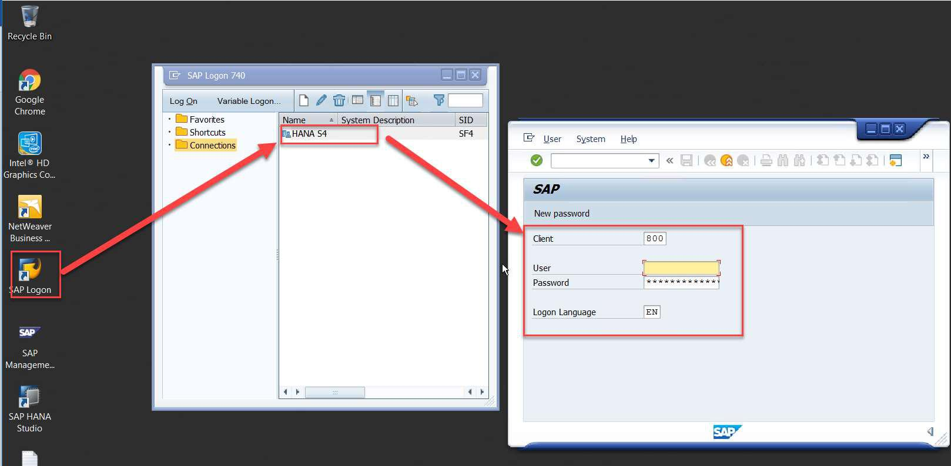

**Connecting to ABAP system from Your own Laptop**

**You can connect to SAP ABAP system from local computer from below tools**

**SAP GUI**

**If you do not have SAPGUI, Please download and install from here**

**https://drive.google.com/file/d/0Bzj4BI3ecRchNzBvWGtwWlN3dnc/view?usp=sharing**

**1.** **Add below system in your SAP GUI by using Create option.**

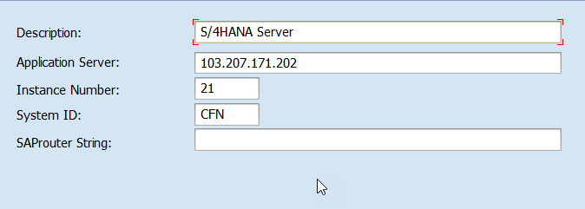

**Description: S4HANA**

**Application Server: 103.207.171.202**

**Instance Number: 21**

**System ID: CFN**

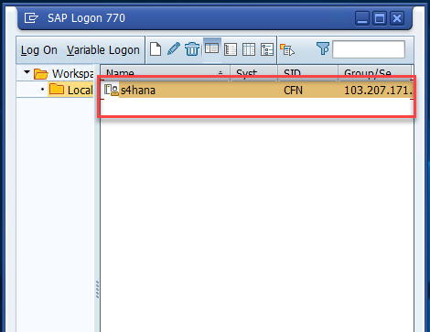

**Once server added as above you can simply connect to it by your credentials.**

**Eclipse with ADT (ABAP Development Tools in Eclipse)**

1. **Please install Eclipse Latest version as per https://tools.hana.ondemand.com/#abap**
2. **Make sure you have setup ADT as per training given by Anubhav.**
3. **You can now choose eclipse menu, open perspective and choose ABAP perspective**

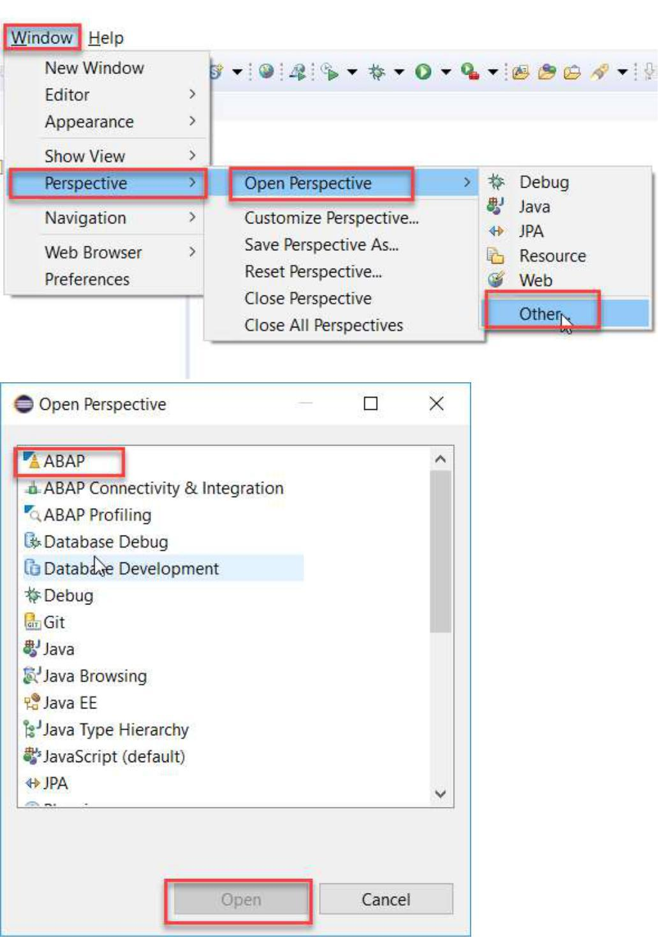

**4.** **Right click on project explorer and Add new ABAP project**

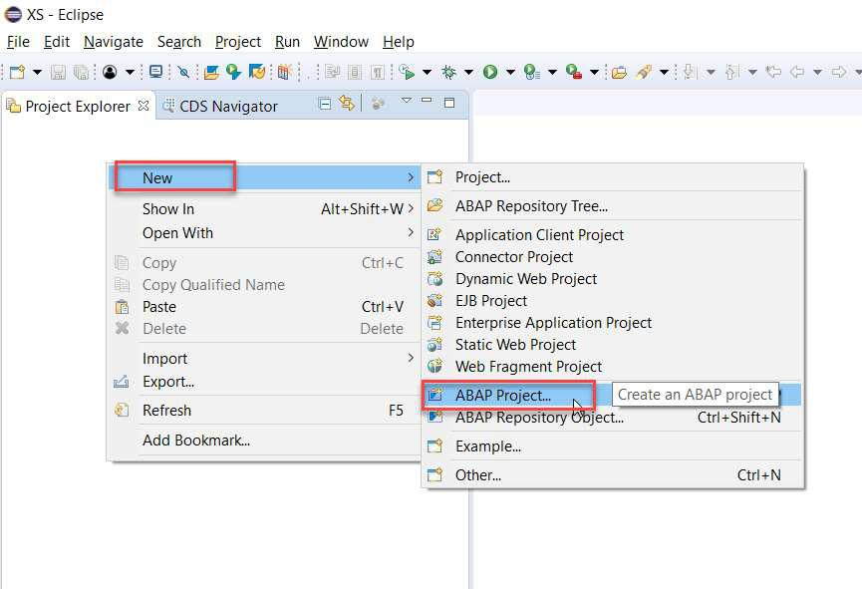

**5.** **Choose ABAP system from SAP GUI view which shows as below**

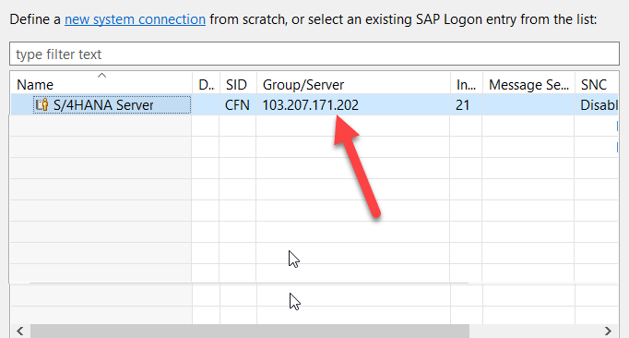

**6.** **Enter your credentials, You are connected to ABAP from local Eclipse.**

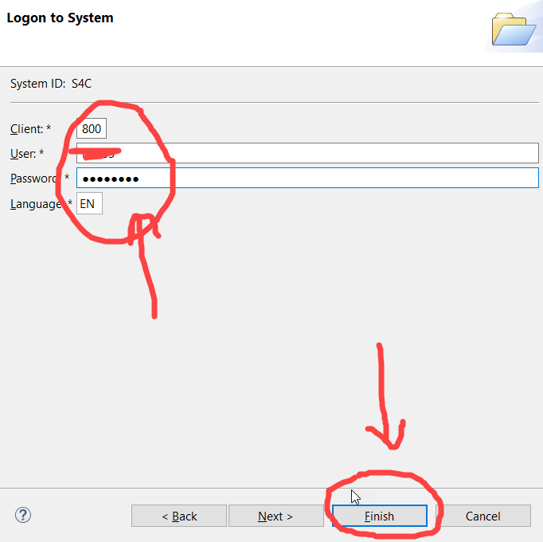

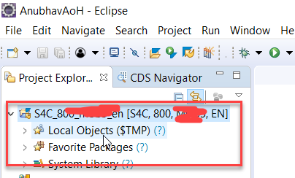

**Setup Local access to OData from SAP WebIDE personal edition**

**If you are using SAP WebIDE personal edition, or want to practice Anubhav learning series with Fiori on ABAP on HANA, you may want to connect ABAP server from local WebIDE by creating destination in SAP WebIDE.**

**You are new to SAP WebIDE personal Edition ☹, Here are some cool video for you ☺**

[**https://www.youtube.com/watch?v=GlcpptK221A&t=37s**](https://www.youtube.com/watch?v=GlcpptK221A&t=37s)

**https://www.youtube.com/watch?v=1KACIrCTo04&t=4s**

**Please download following 2 files attached**

1. **Hosts file: Please replace the below file in your windows laptop @ below location C:\Windows\System32\drivers\etc**

**Please rename existing file in your system, just in case**

**Link:** [**https://drive.google.com/file/d/1d1QvvmWSDFJJvxPQx4VYoNC0sSUbYsD1/view?usp=sharing**](https://drive.google.com/file/d/1d1QvvmWSDFJJvxPQx4VYoNC0sSUbYsD1/view?usp=sharing)

1. **CFN Destination file: Please place this file in your WebIDE installation directory, inside the destination folder.**

**For example: SAP WebIDE personal Edition is installed on D:\MyWebIDE folder. So the location will be**

**D:\MyWebIDE\eclipse\config_master\service.destinations\destinations**

**Link:** [**https://drive.google.com/file/d/100VNeT_7kU66OuF3LpWIsmWn083fychT/view?usp=sharing**](https://drive.google.com/file/d/100VNeT_7kU66OuF3LpWIsmWn083fychT/view?usp=sharing)

**Note: Those who already using server change neo-app.json destination to CFN now**

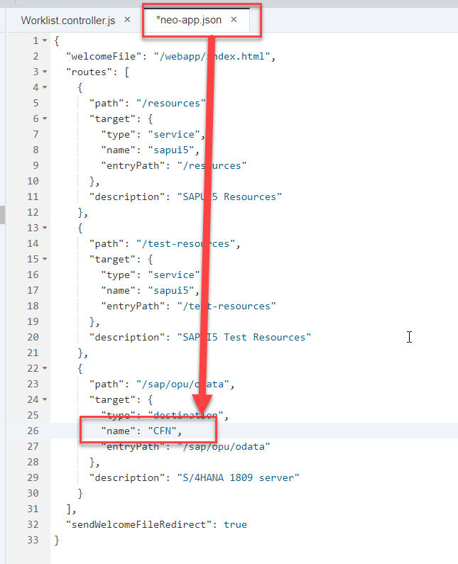

**Test using below URL if Connection to OData works using below**

[**http://s4dev.st.com:8021/sap/opu/odata/IWBEP/GWSAMPLE_BASIC/?$format=xml**](http://s4dev.st.com:8021/sap/opu/odata/IWBEP/GWSAMPLE_BASIC/?$format=xml)

**Fiori LPD url of Anubhav’s server**

[**http://s4dev.st.com:8021/sap/bc/ui5_ui5/ui2/ushell/shells/abap/Fiorilaunchpad.html#Shell-home**](http://s4dev.st.com:8021/sap/bc/ui5_ui5/ui2/ushell/shells/abap/Fiorilaunchpad.html#Shell-home)

**LPD Designer URL**

[**http://s4dev.st.com:8021/sap/bc/ui5_ui5/ui2/ushell/shells/abap/Fiorilaunchpad.html#Shell-home**](http://s4dev.st.com:8021/sap/bc/ui5_ui5/ui2/ushell/shells/abap/Fiorilaunchpad.html#Shell-home)

[**http://s4dev.st.com:8021/sap/bc/ui5_ui5/sap/arsrvc_upb_admn/Main.html?sap-client=800?SCOPE=CONF&sap-language=EN#/Catalog**](http://s4dev.st.com:8021/sap/bc/ui5_ui5/sap/arsrvc_upb_admn/Main.html?sap-client=800?SCOPE=CONF&sap-language=EN#/Catalog)

**S/4HANA 2021 Content manager tool**

[**http://s4dev.st.com:8021/sap/bc/webdynpro/sap/sui_tm_mm_app?sap-client=800&sap-language=EN#**](http://s4dev.st.com:8021/sap/bc/webdynpro/sap/sui_tm_mm_app?sap-client=800&sap-language=EN#)

**S/4HANA Key User Extensions in OP**

**Please assign below Roles to your user in PFCG for key user extensions**

**SAP_NW_APS_EXT_CFD**

**SAP_NW_APS_EXT_CFL_APP**

**SAP_UI_FLEX_KEY_USER**

**ZBCR_ANUBHAV_EXT**

Please use Internet Explorer for time being

**Once above two steps are done, restart your WebIDE personal edition. Now you can create project from template and you will find all OData services in the destination.**

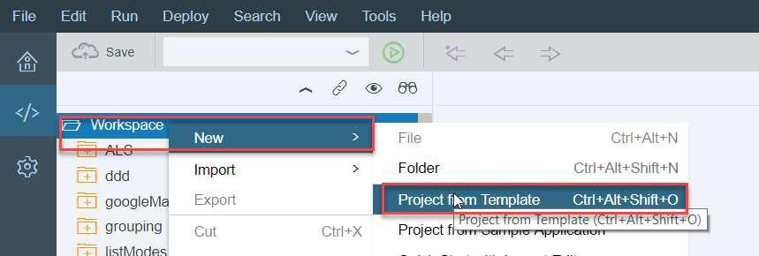

**Please use your ABAP system credentials to connect, you will see all OData services as below.**

**If you using SAP WebIDE Full Stack as demoed here**

[**SAP WebIDE Full Stack Training | SAP Fiori Launchpad Security Concepts | Build Fiori using Grunt.js**](https://www.youtube.com/watch?v=xJbqq1xadVk)

**Good news!! No need of cloud connector with our server :)**

**Here is config for destination in SAP Cloud Platform under Connectivity > Destination**

**Here is direct file which you can upload**

[**https://drive.google.com/file/d/13vkYOdibyT-fL41EYqNl2wDZfw3asukS/view?usp=sharing**](https://drive.google.com/file/d/13vkYOdibyT-fL41EYqNl2wDZfw3asukS/view?usp=sharing)

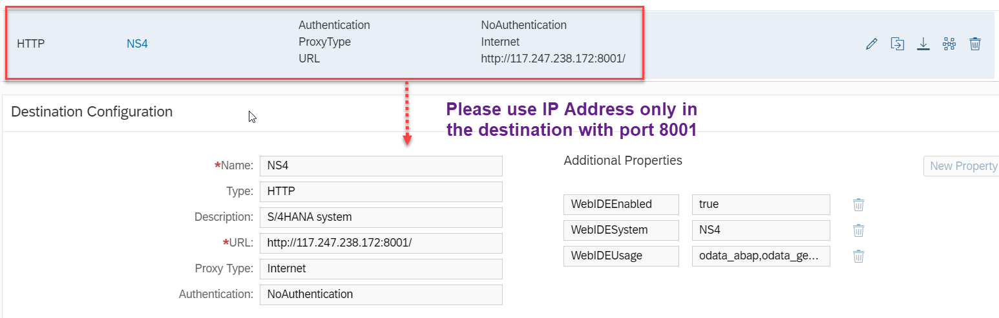

**[NEW] if you using BAS- Business Application Studio, please use below destination file**

**Please UPLOAD THE SAME TO Cloud Foundry, Cloud platform, Business Technology platform**

[**https://drive.google.com/file/d/1dwDp2NE6smNfHTT8Ik9kRWpfn6bUsTFA/view?usp=sharing**](https://drive.google.com/file/d/1dwDp2NE6smNfHTT8Ik9kRWpfn6bUsTFA/view?usp=sharing)

**Configure Cloud Connector (only needed if you are using HANA Cloud Platform) – Not Mandatory for the majority of you.**

**Here is video: https://www.youtube.com/watch?v=Cx3cXAEcnUs**

**Other server options: https://youtu.be/QNgudHbbHvM**